INTRO: B F#

B F# B
Well there's a certain girl I've been in love with a long long time
B
(What's her name?) I can't tell ya (Aww)
B F# B
I can't reveal her name until she's mine
B
(What's her name?) I can't tell ya (Aww)

G#m (with F#m) G#m

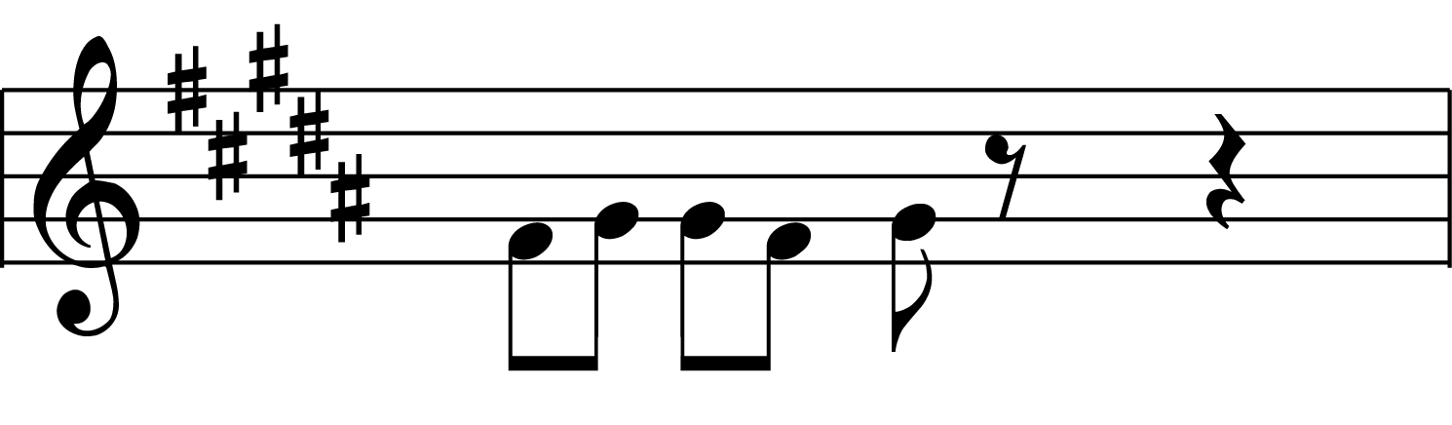

I've tried to make her time and time again

G#m G#m
Still we're introduced as nothin' but friends
B F# B
And there's a certain girl I've been in love with a long long time
B
(What's her name?) I can't tell ya (Aww)

B F# B
There's a certain chick I've been sweet on since I met her
B
(What's her name?) I can't tell ya (Aww)
B F# B
I can't reveal her name until I get her
B
(What's her name?) I can't tell ya (Aww)

G#m G#m
Someday I'm gonna wake up and say (yeah...)
G#m G#m
I'll do anything just to be your slave
B F# B
And there's a certain girl I've been in love with a long long time
B
(What's her name?) I can't tell ya (Aww)

SOLO: B F# B F# G#m B F# A

B F# B
There's a certain girl I've been in love with a long long time
B
(What's her name?) I can't tell ya (Aww)
B F# B
I can't reveal her name until she's mine
B
(What's her name?) I can't tell ya (Aww)

G#m G#m
I've tried to make her time and time again (Yeah...)
G#m G#m
And still we're introduced as nothin' but friends
B F# B
And there's a certain girl I've been in love with a long long time
B
(What's her name?) I can't tell ya (Aww)

B
I can't tell ya (What's her name?)
B
I can't tell ya (what's her name?)
B
I can't tell ya (what's her number?)
B
I can't tell ya (Aww)
B
I can't tell ya (what's her name?)
B
I'm afraid not (what's her name?)
B
I can't tell ya (what's her number?)
B
I can't tell ya (Aww)
B
I can't tell ya (what's her name?)...

